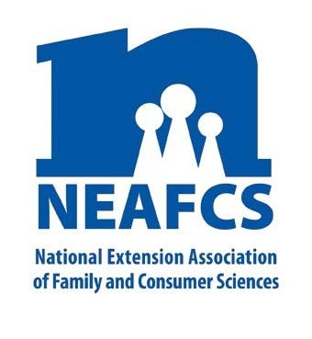
IMPACT 2014

Through Extension programs across the nation, Family and Consumer Science Extension Educators provide a multitude of educational opportunities to meet the needs of diverse audiences.

Community Health and Wellness

Promoting healthy lifestyle choices to improve physical health and prevent illness or disability is a core goal of Extension Family and Consumer Science programming. Within Extension, health educators collaborating with nutrition, family life and 4-H educators as well as with agencies, partners, and businesses with healthy family goals, provide opportunities to improve the health status of all residents in state and local communities.

Worksite programs

Creating Balance with Food & Fitness in-depth food and fitness courses were delivered through interactive, hybrid webinars over the noon hour for seven weeks and recorded for archived viewing to Nebraska residents. Participants made statistically significant, positive changes in goal setting, physical activity, using food labels to make healthier choices, eating more fruits and vegetables, monitoring portions, and eating foods lower in fat, sugar and sodium.

The Worksite Wellbeing programming by South Dakota Extension and its partners provided resources to worksites in a variety of formats to promote and enhance worksite well-being programming. The SD Voices for Food project has fostered a learning community within a six state area, resulting in a greater understanding of food security issues. SD’s EFNEP classes taught 5,807 youth how to develop healthy eating habits, choose healthy snacks, become more active, and practice safe food handling.

NEAFCS National Office | 20423 State Road 7, Suite F6-491 | Boca Raton, FL 33498
(561) 477-8100 | FAX (561) 910-0896 | www.neafcs.org

Increasing Physical Activity

In Montana Extension educators offered 25 programs reaching a total of 2204 participants designed to help them increase their knowledge of safe and effective physical activity habits with an emphasis on strength training. Long-term, broad-reaching impacts included an increase in the number of opportunities to access physical activity focused on strength training at home and in communities. Strong Women programs empower middle and older aged women to improve their muscle mass and achieve greater physical fitness.

“I lost 17 pounds and my cocker spaniel lost
three pounds. We did a lot of walking
together.” -- Walk Kansas participant

In Kansas, more than 15,700 persons enrolled in 103 Walk Kansas programs; 49% reported increased energy, 43% better attitude, 38% Increased endurance, 32% improved sleep, 25% decreased weight 25%, increased muscle strength, 22% increased flexibility, and 11% lowered their blood pressure. Over 2,970 walking programs were held by Arkansas FCS educators reaching 18,492 individuals who reported losing weight, walking every day, and monitoring portion sizes. In North Dakota, more than 8,700 fourth graders took part in a five-week “Banking on Strong Bones” program with post-survey results showing that 63% were drinking more milk.

Mississippi has been offering Strong Bones, Strong Women classes in Stone County since 2005. Over the

years, 95 ladies have participated in the twice a week, hour-long session of weight bearing and aerobic
exercise. At age 72, the instructor had a bone density test that was pronounced as “super” by her physician who told her to “keep up” her exercise regimen. In Saratoga County, New York, 10 individuals took part in a twice weekly, six- week long Strong Women, Healthy Hearts class.
“I have enjoyed the introduction of different food choices, the experience of different exercise programs, and the overall benefits of being around individuals who are striving to improve their overall health without the stigma of being perfect.”
—New York Strong Women, Healthy Hearts class participant

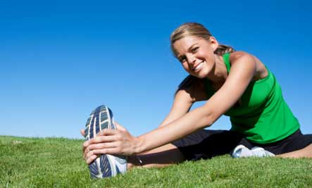
The State Fair Food Finder app, developed through a private/public partnership between the Des Moines Register and Iowa Extension and Outreach, increased access to nutrition and physical activity information, achieving more than one million views in 2013.
Brain Development/Injury
Georgia Extension staff prepared 49 Better Brains for Babies (BBB) educators to teach early brain development. BBB educators reached more than 1,900 parents and professionals with more than 6,400 contact hours of group and individualized training.
A USDA grant provided Kansas FCS educators with funding to develop “TBI Options: Promoting Knowledge” to raise awareness about traumatic brain injury as well as increase support for survivors and their families. Two hundred twenty individuals have been assisted by this effort.
This report was compiled by Judith Breland, Mississippi State University Extension Service, Public Affairs Advocacy Subcommittee member, and Theresa Mayhew, Cornell Cooperative Extension, Vice President -- Public Affairs. For more information, email tcm5@cornell.edu.

